Power Supply :-

The basic step in the designing of any system is to design the power supply required for
that system. The steps involved in the designing of the power supply are as follows,

1) Determine the total current that the system sinks from the supply.
2) Determine the voltage rating required for the different components.
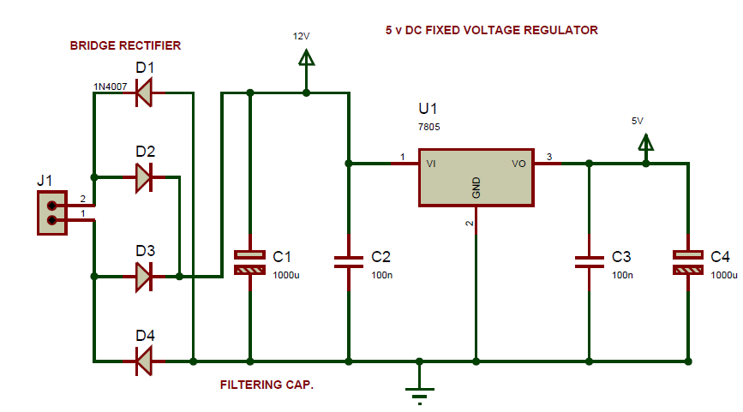
The bridge rectifier and capacitor i/p filter produce an unregulated DC voltage which is applied at the I/P of 7805.As the minimum dropout voltage is 2 for IC 7805, the voltage applied at the input terminal should be at least 7 volts .
C1 (1000 µf / 65v)is the filter capacitor and C2 and C3 (0.1 pf) is to be connect across the regulator to improve the transient response of the regulator.
Assuming the drop out voltage to be 2 volts, the minimum DV voltage across the capacitor C1 should be equal to 7volts (at least).
Power supply design of the Project:
The average voltage at the output of a bridge rectifier capacitor filter combination is given by
Vin(DC) = Vm – Idc / 4 f C1
Where , Vm=√2 Vs and Vs = rms secondary voltage
Assuming Idc to be equal to max. load current, say 100mA
C = 1000 Gf / 65v , f=50hHz

19 = Vm – 0.1 / 4*50*1000*10¯6
19= Vm – 0.1 / 0.2
Vm=19.5 volts
Hence the RMS secondary Voltage
Vrms = vm / √2
= 19.5 / √2
=19,5 / 1.4421
=13.5 volts
So we can select a 15v secondary Voltage
In our system most of the components used require 5 V as operating voltage such as micro controller, MAX 232, MCT2E etc. The total current, which our circuit sinks from the power supply, is not more than 100 mA. We have used Regulator IC 7805 that gives output voltage of 5V.The minimum input voltage require for the 7805 is near about 7 v. Therefore we have used the transformer with the voltage rating 230v-10v and current rating 500 mA. The output of the transformer is 12 V AC. This Ac voltage is converted into 12 V DC by Bridge rectifier circuit.
The reasons for choosing the bridge rectifier are
- The TUF is increased to 0.812 as compared the full wave rectifier.
- The PIV across each diode is the peak voltage across the load =V_{m}, not 2V_{m} as in the two diode rectifier
Output of the bridge rectifier is not pure DC and contains some AC some AC ripples in it. To remove these ripples we have used capacitive filter, which smoothens the rippled out put that we apply to 7805 regulators IC that gives 5V DC. We preferred to choose capacitor filters since it is cost effective, readily available and not too bulky.

